**Centrality**

The most important vertices of the graph are identified by centrality scores.

What is a graph???

**Degree Centrality:**

This centrality defines the number of edges incident upon a vertex. Indegree and Outdegree can be used. Number of edges pointing towards a node is called Indegree and number of edges pointing to other nodes is called outdegree.

Consider a graph G(V, E), with V as the vertices and E as the edges. The centrality can be calculated as

CD = deg(V)

O(V2) time is taken for the calculation of degree centrality in a dense adjacency matrix whereas O(E) time is taken in a sparse matrix.

Use:

1. The node which has highest risk of catching the disease can be found.
2. Popularity can be gauged using Indegree whereas gregariousness can be gauged using Outdegree.

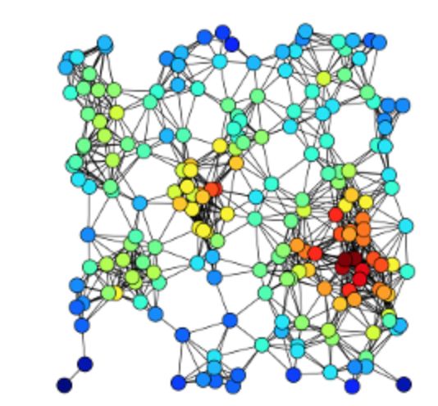

**Closeness Centrality:**

This centrality is defined as reciprocal of sum of length of shortest paths between the node to other nodes. Bavelas defined the centrality as

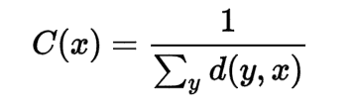

Websites with outgoing link can have high closeness centrality whereas it might be low with incoming links.

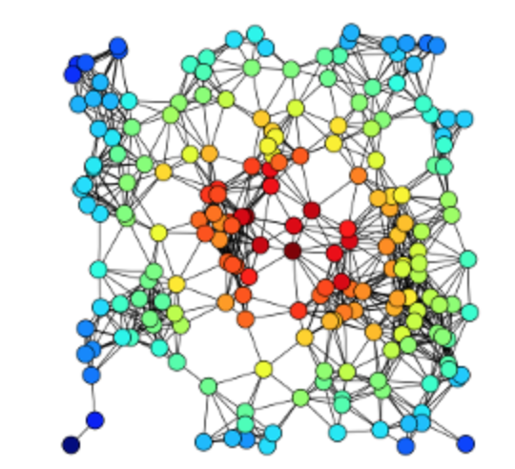

**Betweeness Centrality:**

This is defined by the number of shortest paths that pass through the vertex.

Betweenness Centrality is given by:

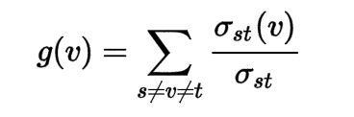

where,

../../../Desktop/Screen%20Shot%202017-12-06%20at%201.20.53%20A {\displaystyle \sigma _{st}}is the total number of shortest paths from node {\displaystyle s}s to node t

../../../Desktop/Screen%20Shot%202017-12-06%20at%201.27.35%20A  is the number of paths that pass through v

So, the shortest paths have to be found and calculated based on the distance.  [Floyd–Warshall algorithm](https://en.wikipedia.org/wiki/Floyd%E2%80%93Warshall_algorithm) will take O(V3) time for finding the shortest paths. On a sparse graph, Johnson and Brandes Algorithm will take O(V2 log V + VE). For unweighted graphs, Brandes Algorithm will take O(VE) time for calculating the centrality.

{\displaystyle t}t

tt t

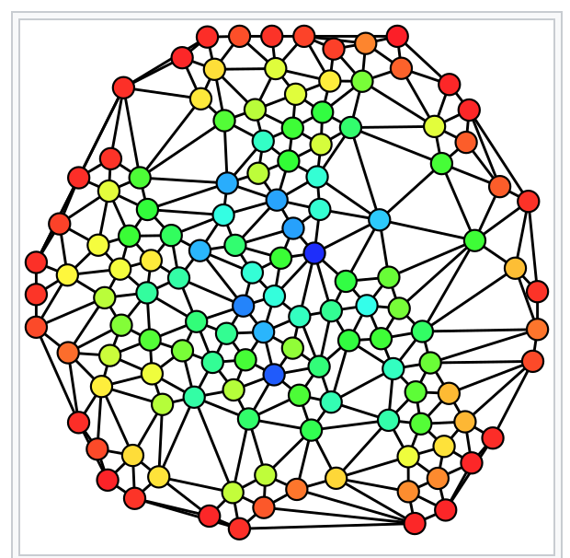

Use:

1. In a telephone network, a node with high Betweenness Centrality will have higher importance as more information will pass through it.

Applications of Centrality:

1. In a social network, the most important people can be identified.
2. Find who can be the gossipmonger among the list of friends.
3. The famous celebrity among a list of celebrities can be found.
4. The source cell responsible for the spread of the disease can be found.
5. The substation which can face the most load in a telephone network can be found.
6. Patterns of Social Relationships can be found.

Limitation:

1. One centrality is not the most optimum centrality for other applications. This gave birth to different centralities.

References:

1. <https://en.wikipedia.org/wiki/Centrality>
2. <https://en.wikipedia.org/wiki/Closeness_centrality>